Bash Scripting

1. Create on Bash script to check if a directory is available or not.

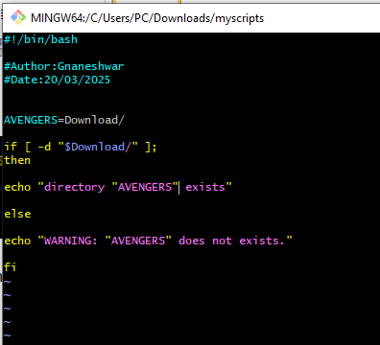

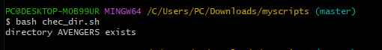

1. Create a bash script which will create multiple files. 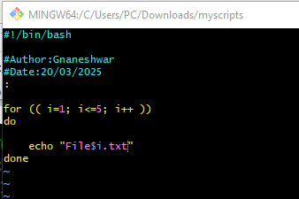

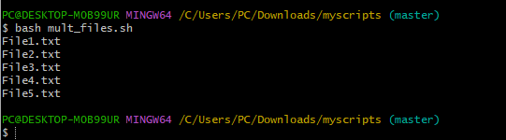

1. Create a bash script to take backup of a directory.

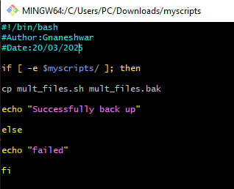 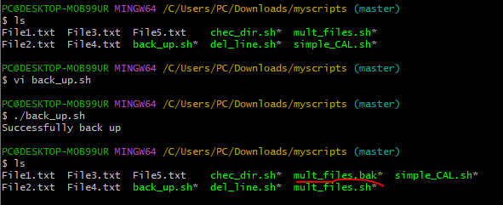

1. Create a bash script to install nginx in ec2 server.

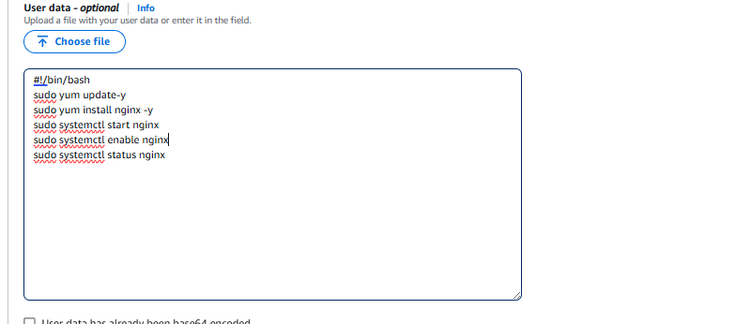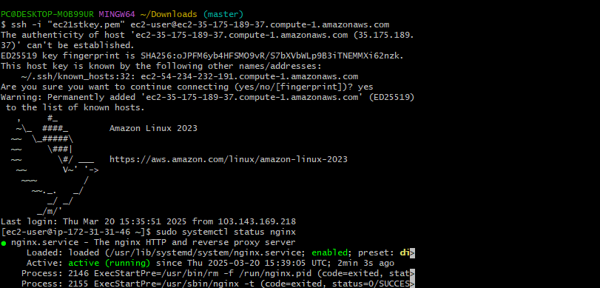

1. Create a bash script to install ApacheTomcat in ec2 server 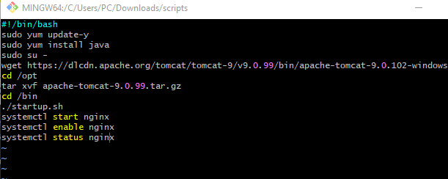

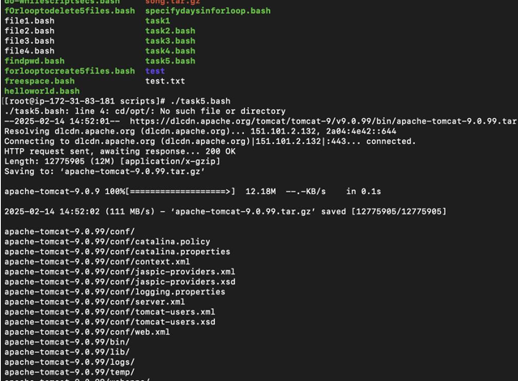 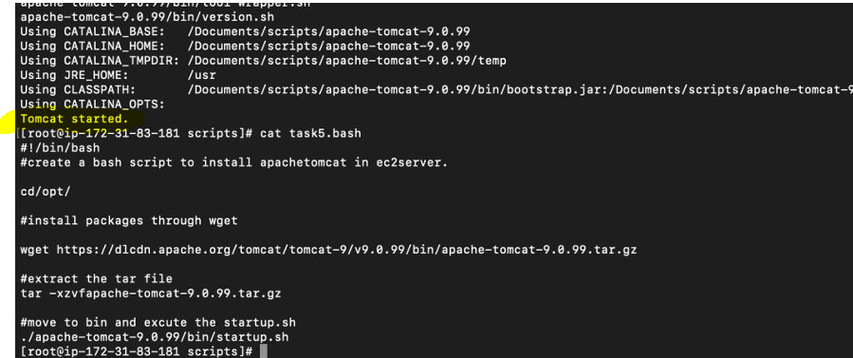

1. Create a bash script to check list if nginx service is running or not,if not running

then script should start the service.

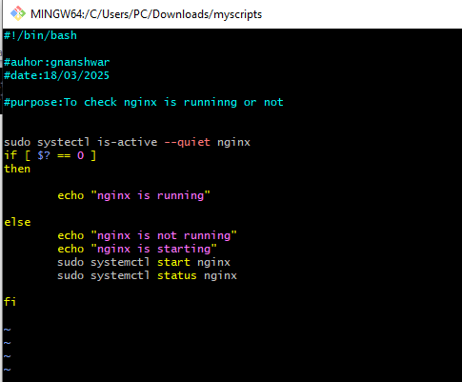

1. Create a bash script for calculator.

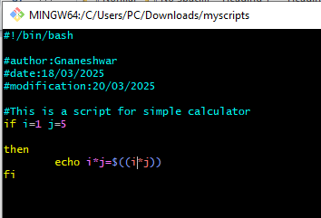

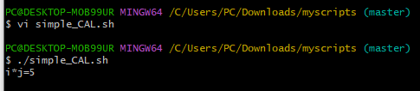

1. Create a bash script to check if directory is avaialble or not,if not then create a directory.

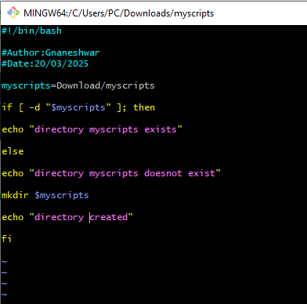 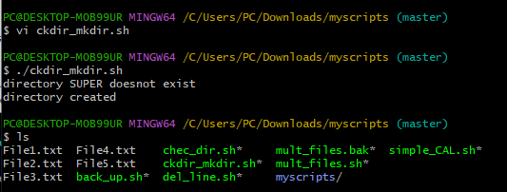

1. Create bash script to delete last 3 lines for a file.

